Mynydd Climbing Club
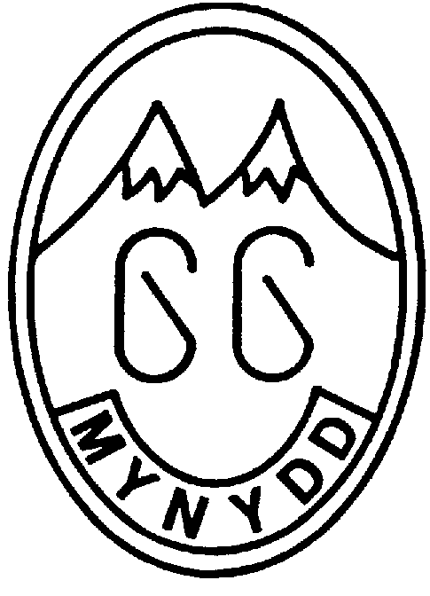
Affiliated to the BMC

HUT RULES

The Hut Rules are framed in order to preserve the traditional atmosphere of freedom associated with the Club and mountaineering while ensuring care of the fabric, cleanliness and facilities of Blaen-y-Nant. Where members are referred to below this refers to members of the Mynydd Climbing Club or members of clubs which have reciprocal rights for use of Blaen-y-Nant.

1. All hut users must sign the hut register.
Payment of hut fees should by BACS to the Mynydd CC bank account.
Sort code: 01 – 05 – 51 Account number: 40582787

2. With the exception of immediate family, members’ guests must be bona fide climbers and walkers. Guests must be accompanied by the member inviting them who is responsible for their compliance with the hut rules.
Aspirants may use Blaen-y-Nant unaccompanied by a member at the discretion of a committee member but may not invite guests.

3. Members may only invite three guests at any time. Should they wish to invite larger groups of people then these groups must be booked in advance with the Hut Booking Secretary.
Immediate family are not included in the above numbers but members are requested to check with the Hut Booking Secretary before using the Hut if they have large families or families containing several adults.

4. The Members Room may only be used by members (not family) and is always available regardless of any hut bookings whether by other clubs and organisations or by members.

5. Hut Users are responsible for keeping the Hut clean and tidy throughout their stay
This includes the domestic tasks outlined below:
a) Bedrooms used must be cleaned and the floors swept.
b) The Living Room and Kitchen must be cleaned and the floors swept.
c) Kitchen surfaces and cookers must be cleaned.
d) All cooking utensils must be emptied and cleaned after every meal.
e) Food, and in particular perishable food, must not be left at the Hut.

6. The Living Room is not a bedroom and must not be slept in. Mattresses must not be removed from the bedrooms.

7. Any damage must be reported to the Hut Warden (hutwarden@mynydd.org.uk) and repaired immediately if possible.

8. Hut equipment must not be removed without prior written permission from the Hut Warden.

9. The Hut Warden (or if unavailable the Hut Booking Secretary) should be informed of any shortages or problems and of any use of First Aid materials or Fire Fighting equipment.

10. Boots and dirty footwear must not be worn upstairs, in the Kitchen or in the Living Room.

11. On leaving the Hut, the instructions listed on the front door must always be complied with. These are:
a) Windows must be secured.
b) Doors must be locked, including the Wood Shed door.
c) Gas and Electricity must be turned off.
d) The water must be turned off and when applicable (see notice) the system should be drained

12. When Blaen-y-Nant is booked to another club or organisation, members of that club or organisation have priority in all bedrooms except the Members room.

13. Only pets belonging to members are allowed in the hut. Non-members’ pets must not be brought into the hut. No pets are allowed into the kitchen or upstairs at any time and must not be allowed to foul the garden and should sleep in cars at night.

14. The committee reserves the right to deal with any contraventions of these rules.

HUT USAGE

a. Hut users are expected to show due consideration and respect for residents of the Crafnant Valley, particularly to those who own and/or farm property adjacent to Blaen-y-Nant. Access through the yard to the large field must always be unrestricted.

b. Blaen-y-Nant is situated in an SSSI (a Site of Special Scientific Interest) and it is important that all hut users do nothing in any way to affect the surrounding environment.

Wood must not be gathered from around the Hut and may only be taken from Forestry Commission areas under the direction of the Hut Warden when a permit for such has been obtained.

c. Hut users are requested to show consideration towards others at Blaen-y-Nant. It is hoped that responsible attitudes will be shown by all, and in particular by, and to the parents of young children, by late night revellers and pet owners.

Hopefully any problems can be resolved by friendly discussion at the time. Failing this, any incidents can be brought to the attention of the Committee for further consideration.

